MCP SERVER INTEGRATION SUITE

To but a mcp server 3 options are available
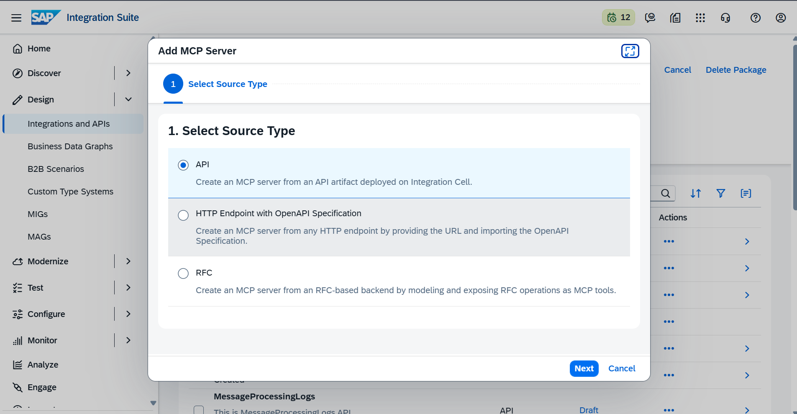

In this tutorial we are going to see Api type as source make sure we already have an api deployed in
Integration cell : we have api url(/api/v1 cpi messageprocessing url) so I going to create one api artifacts before creating mcp server
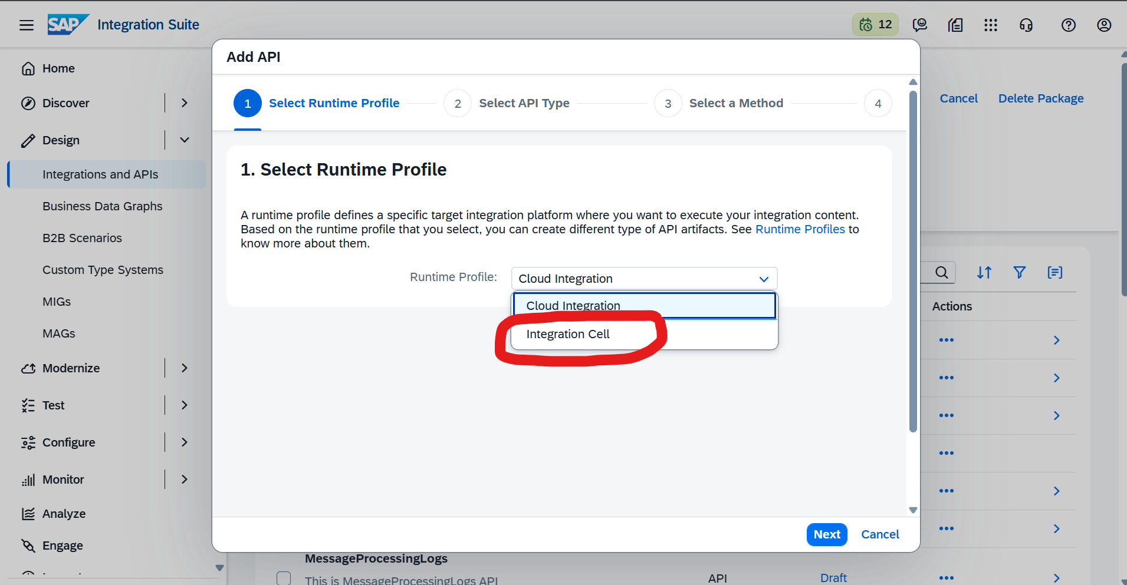
Make sure to select integration cell
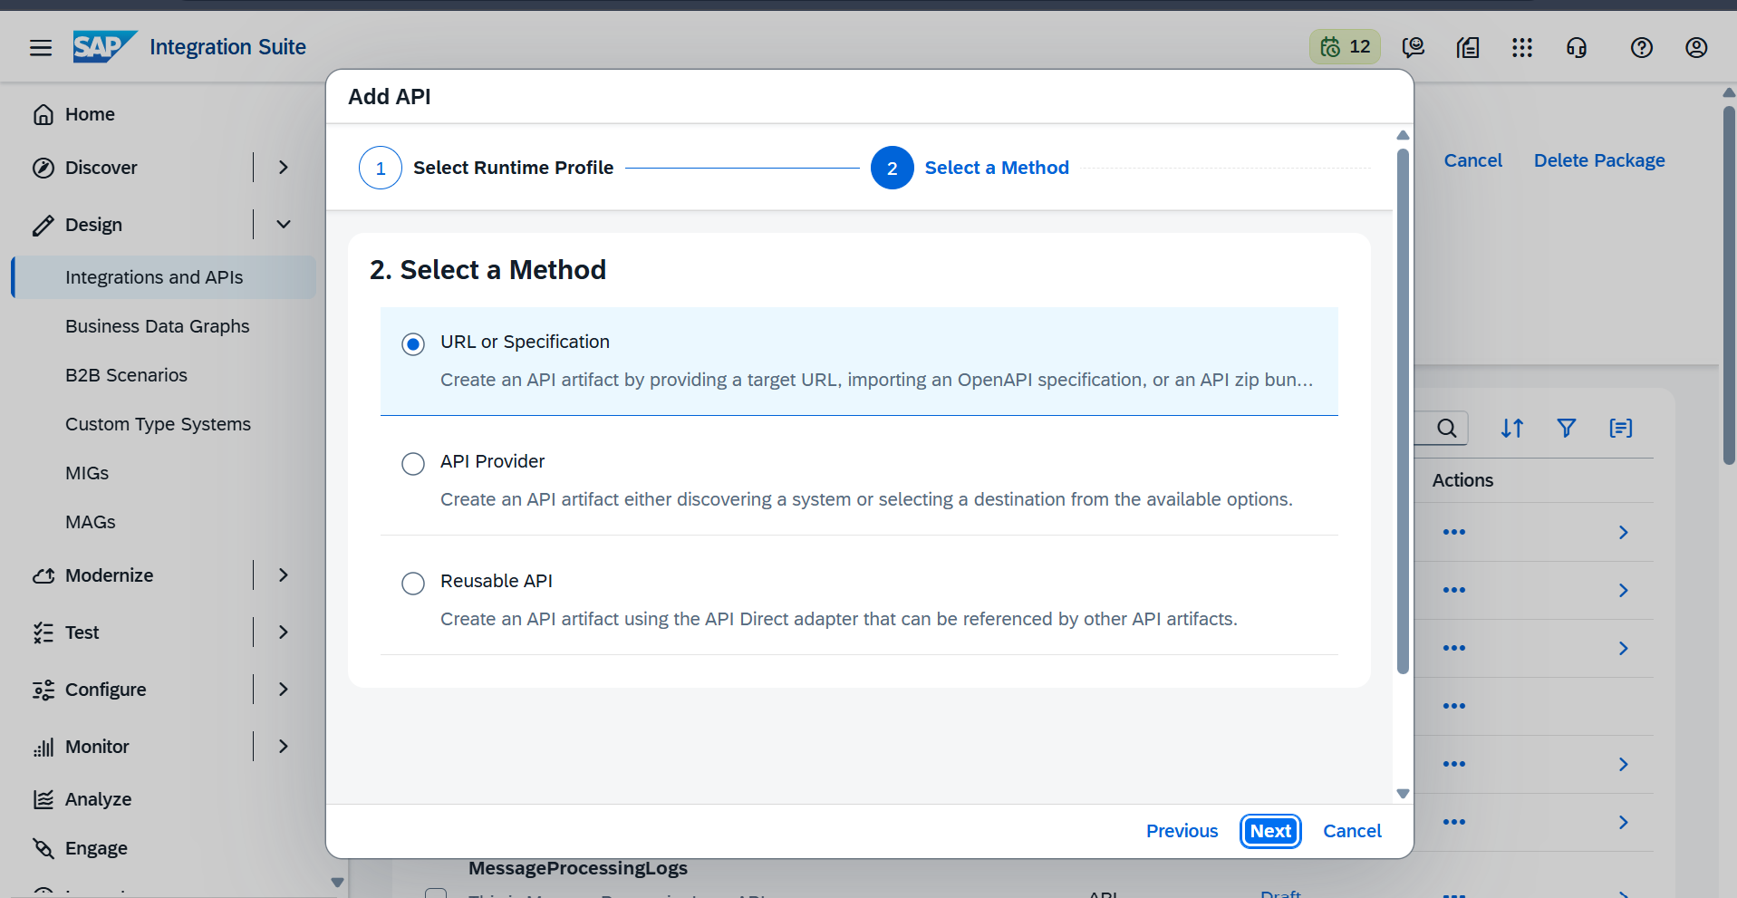
Here we have url so im go with option 1
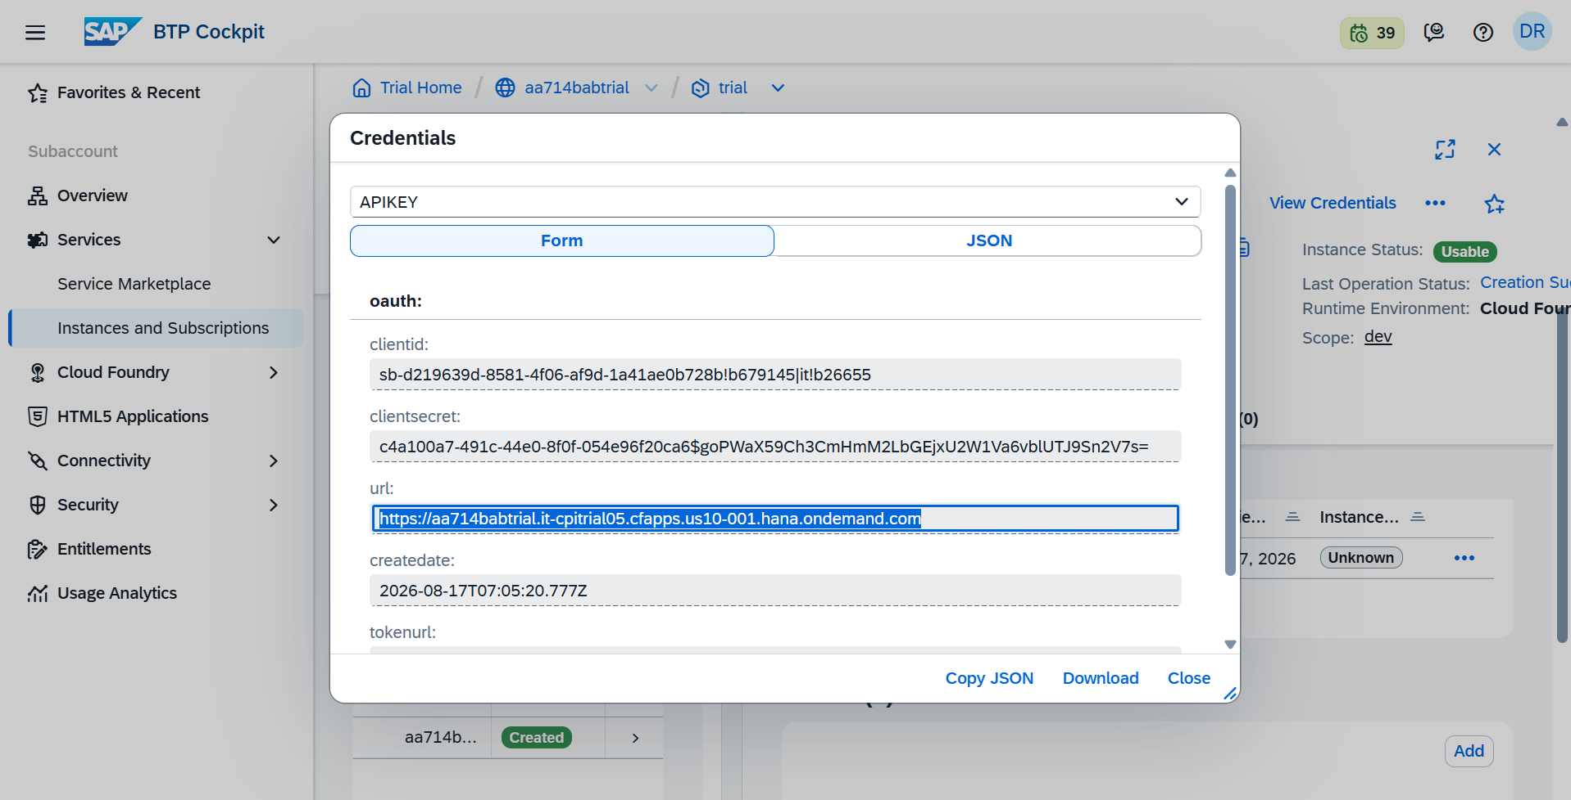
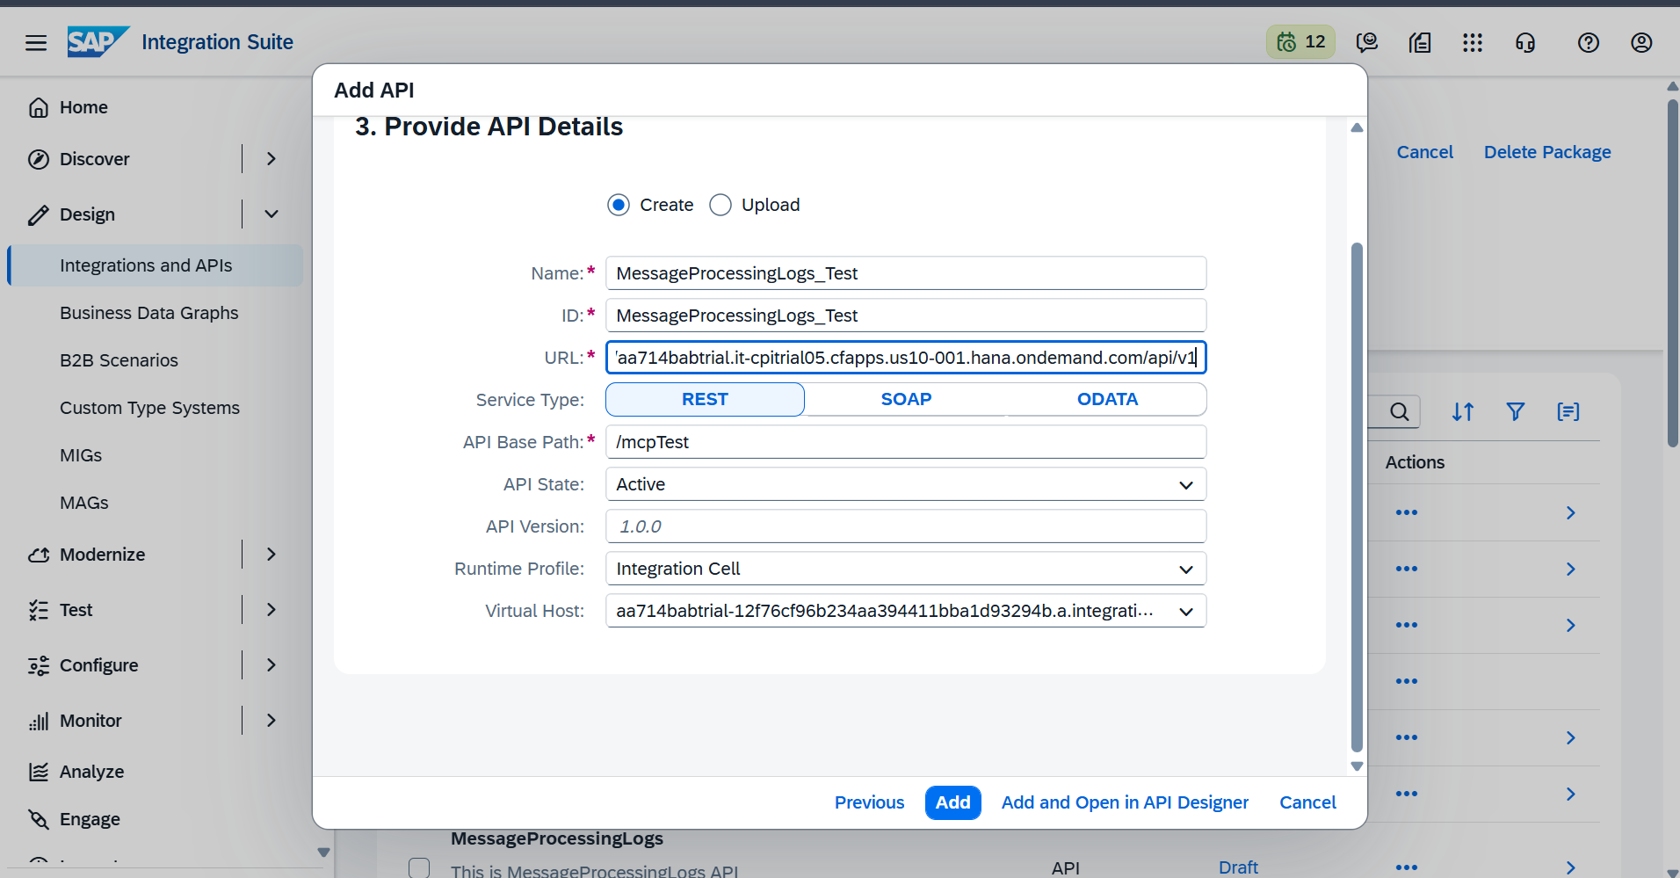
Go to policies tab in authentication select all 3 method basic,oauth,certificate
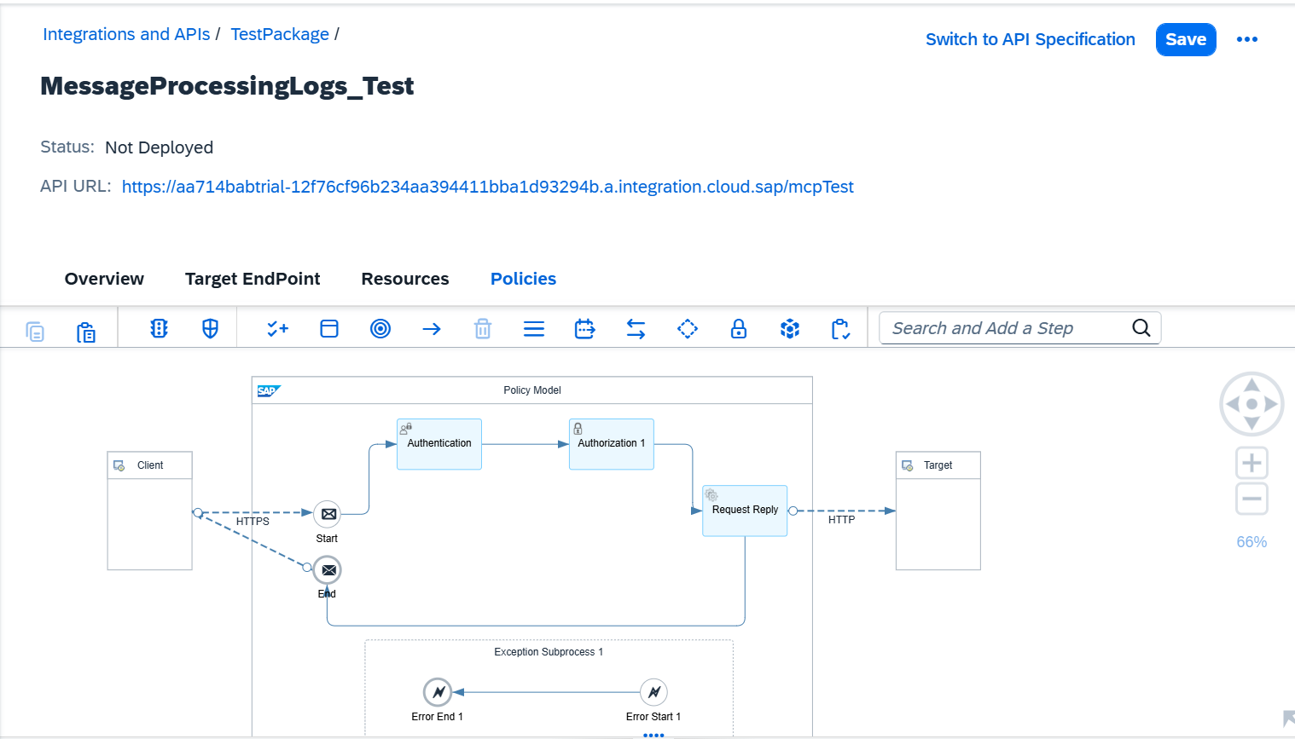
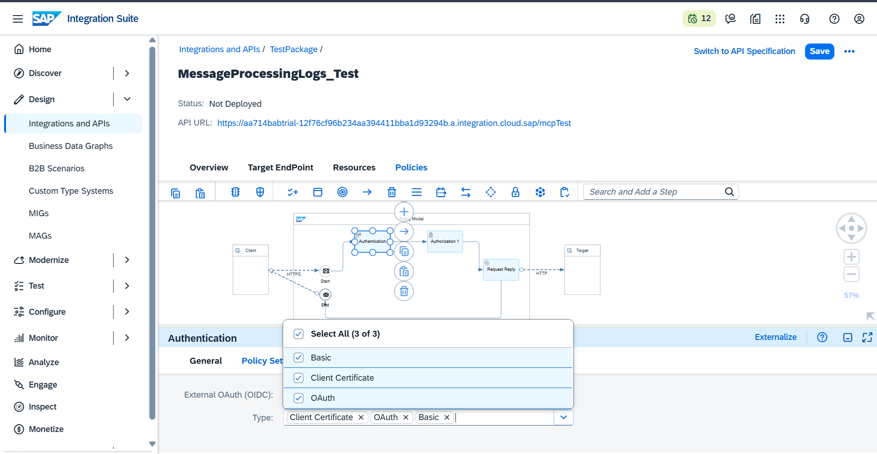
For authorization scope should matches your token details here im gointo use api.invoke or esbmessage.send
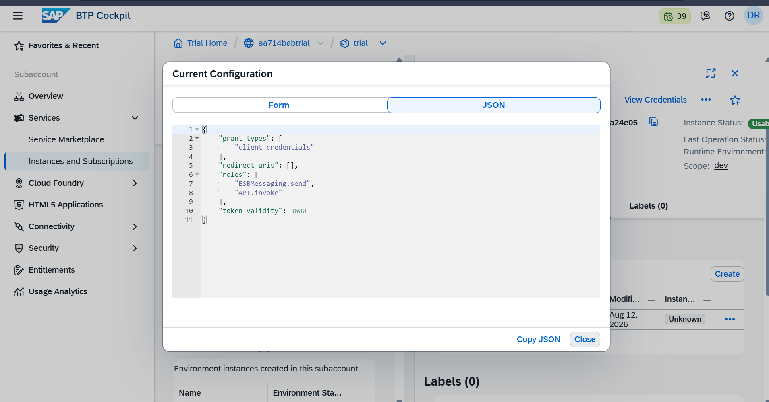
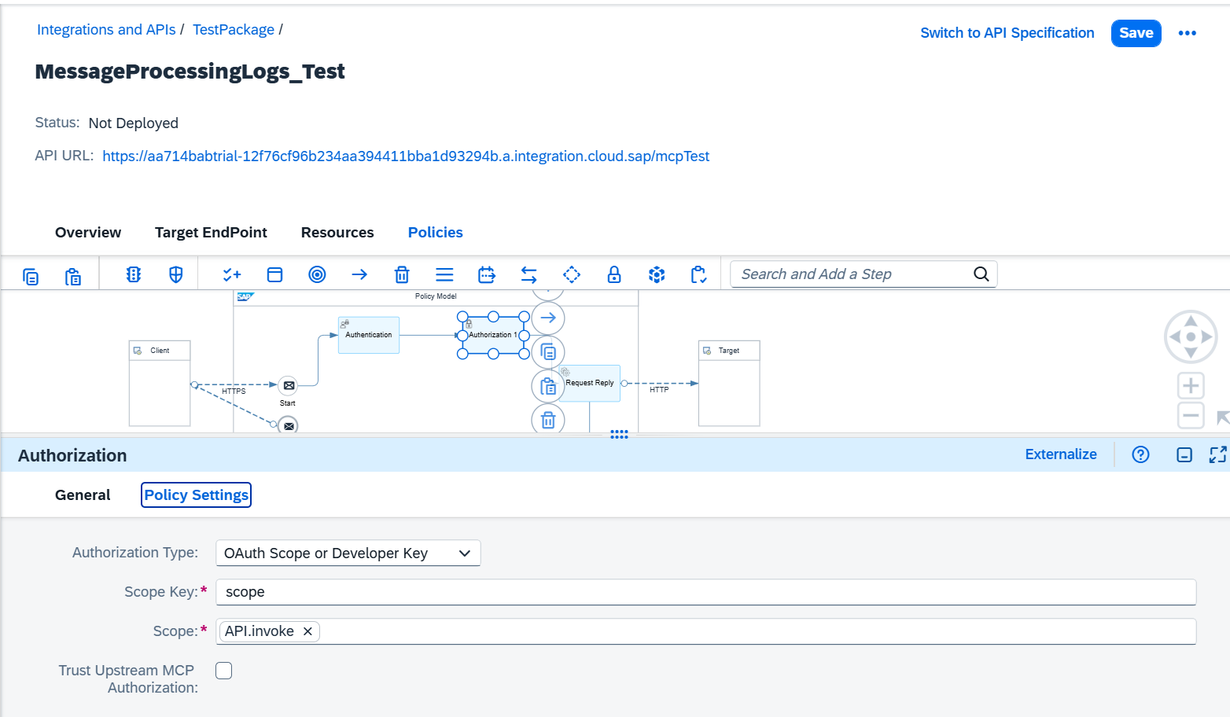
Next go to http adapter add credentials for your urls(message processing log like /api/v1)
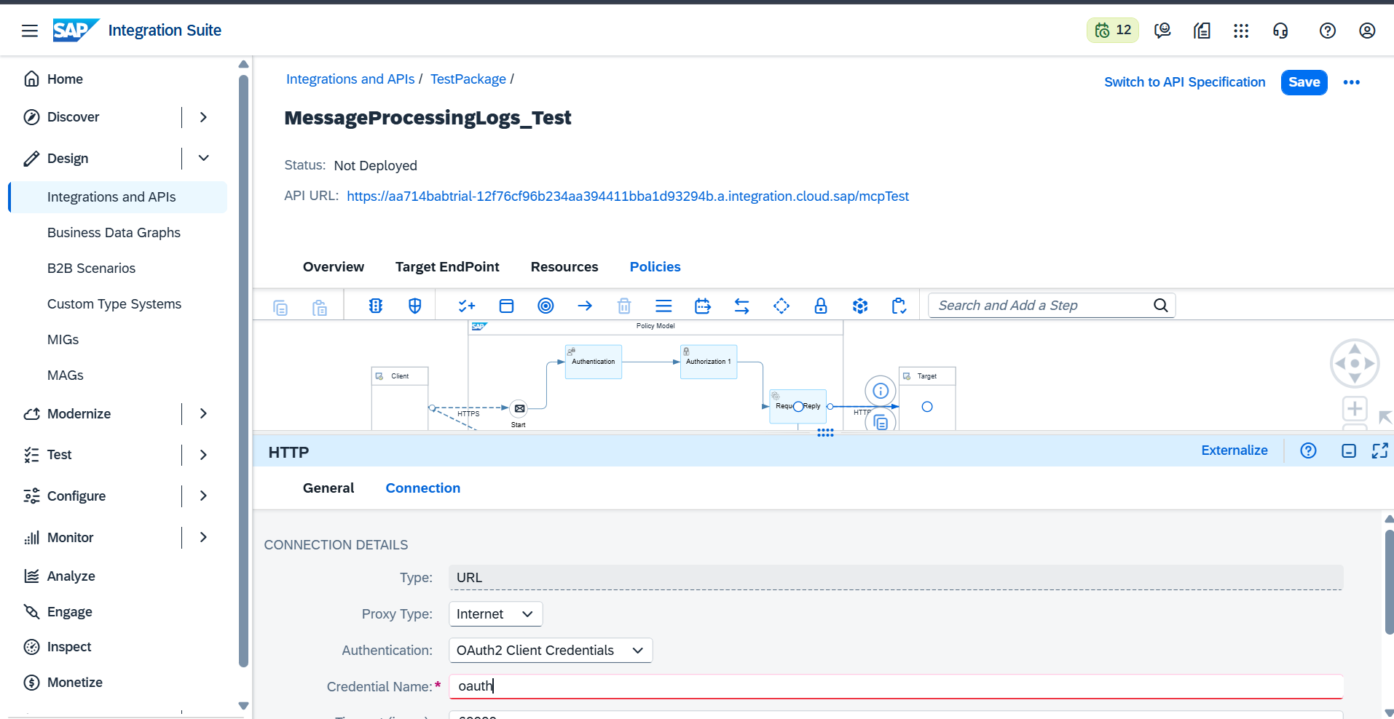

Next Go to resource tab: add resources or you can import metadata of your url edmx file
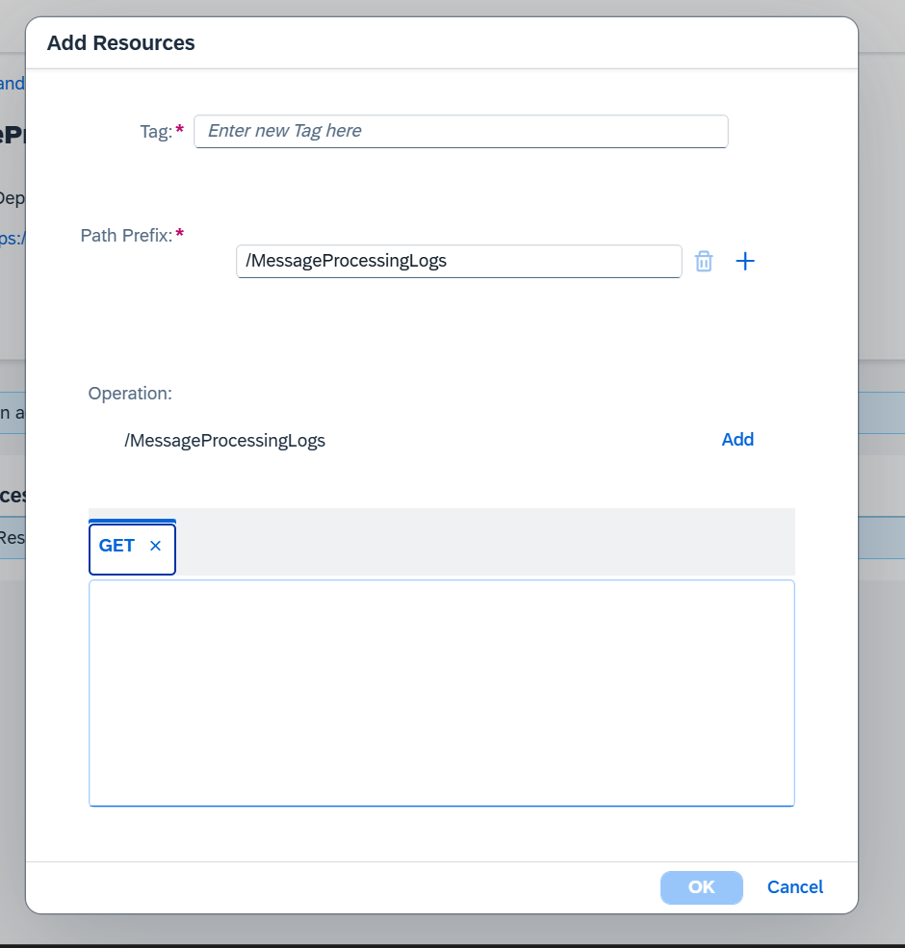

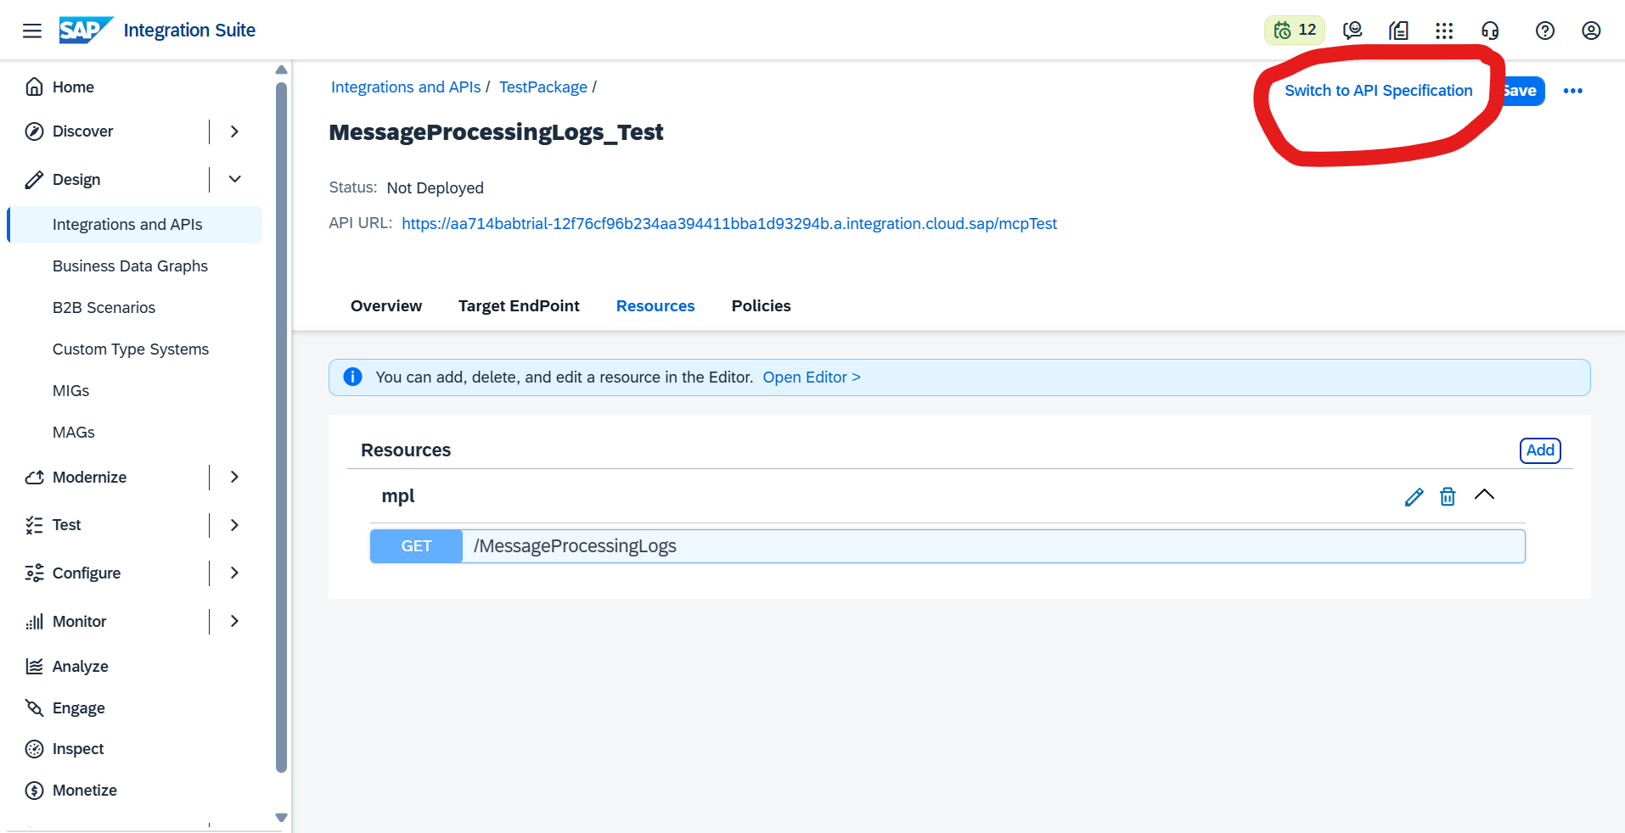

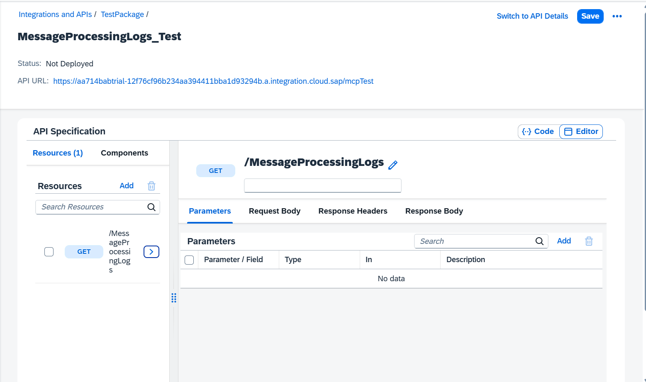
Here add $filter,$top,$inlinecount,$skip,$select,$expand as querry
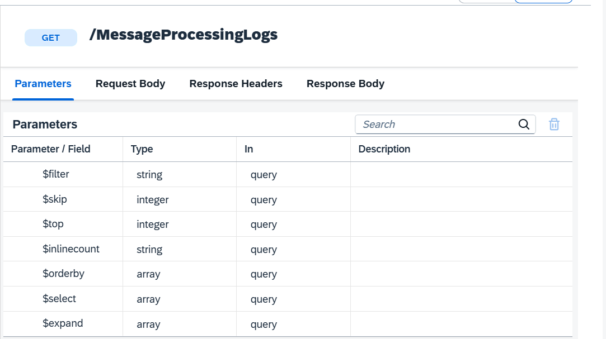

If you added resources like particular messages details in that case parameters should look like this
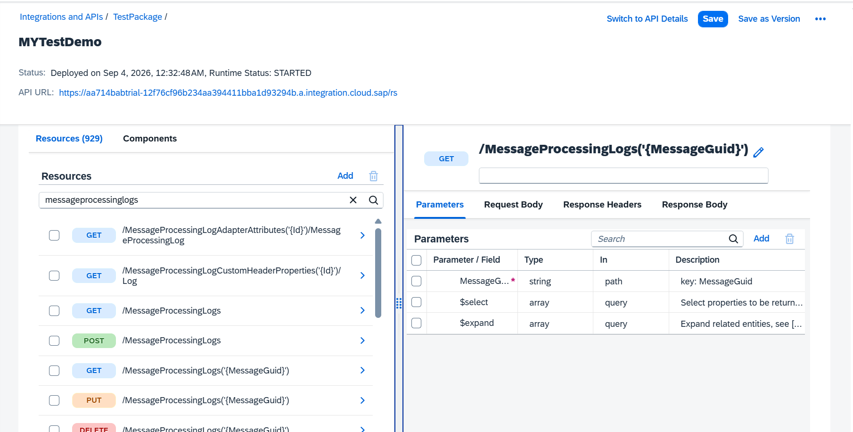
The above screenshot is example of (‘{MessageGuid}’) setting this as path
After adding resources save and deploy
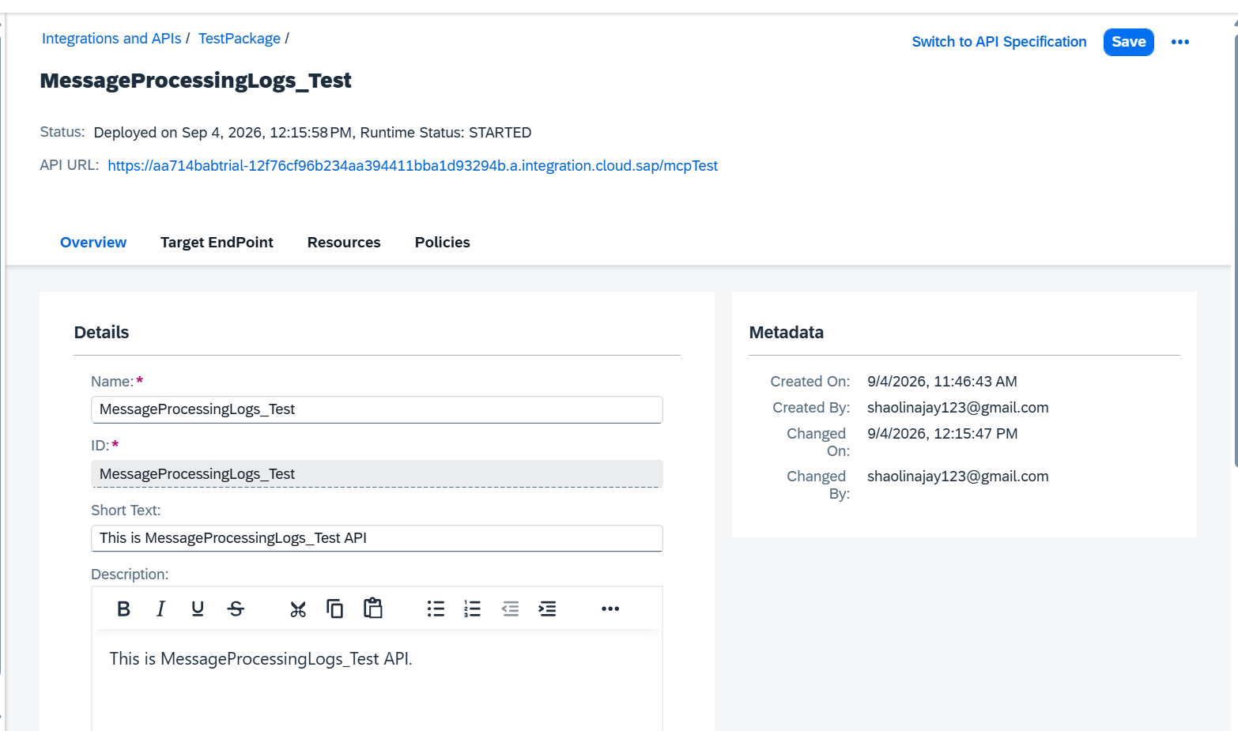

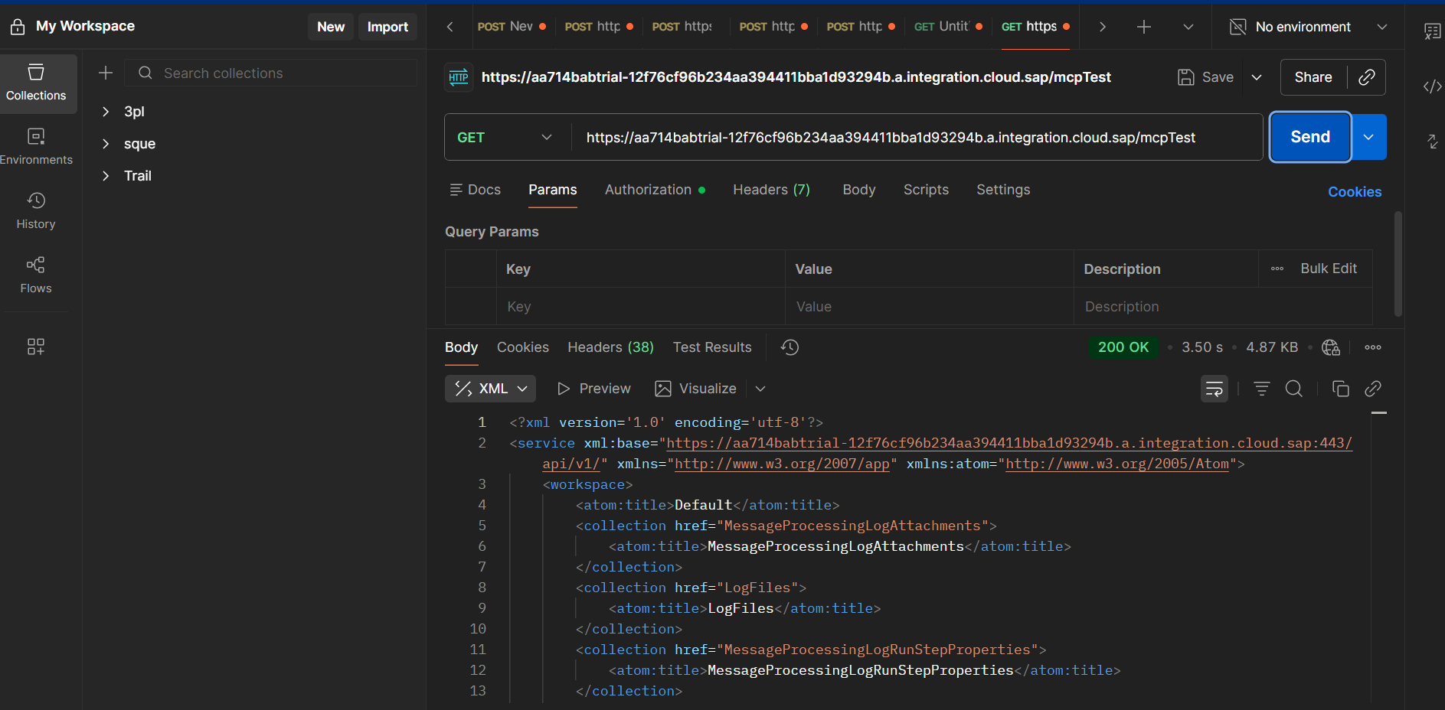
Testing api using postman working fine.

Now build an mcp server:
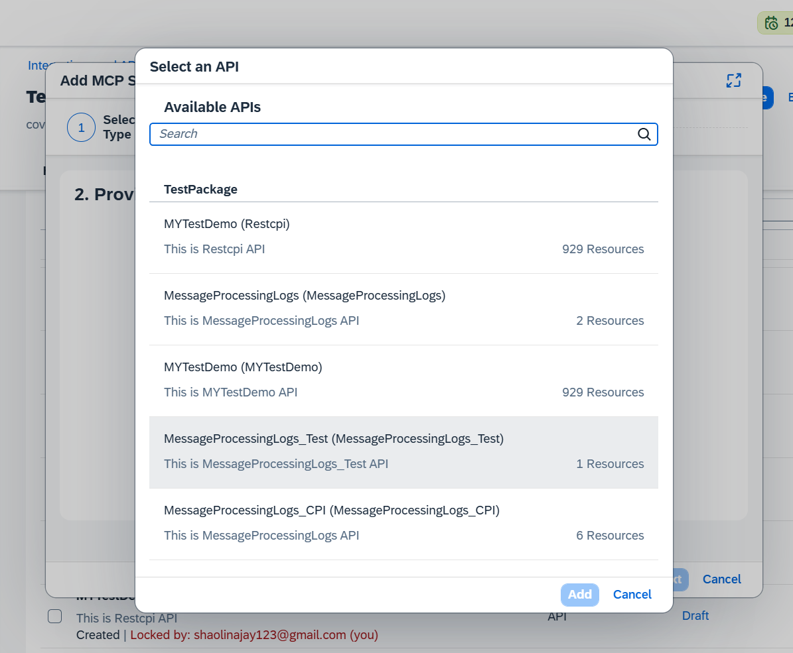
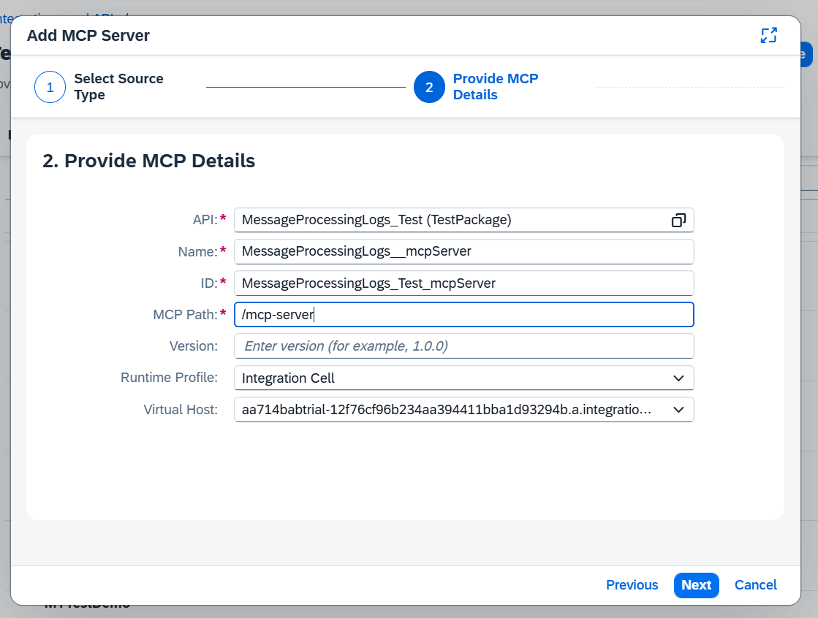
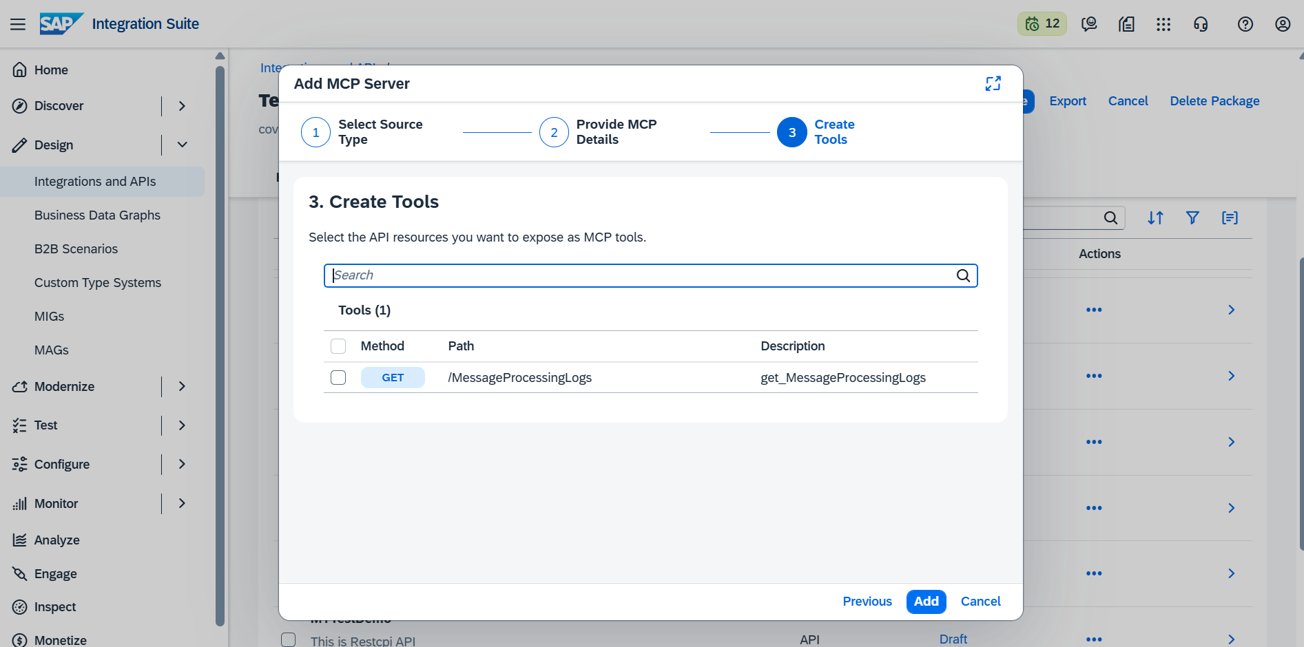
Select all tools available

After save and deploy use the mcp url to Connect
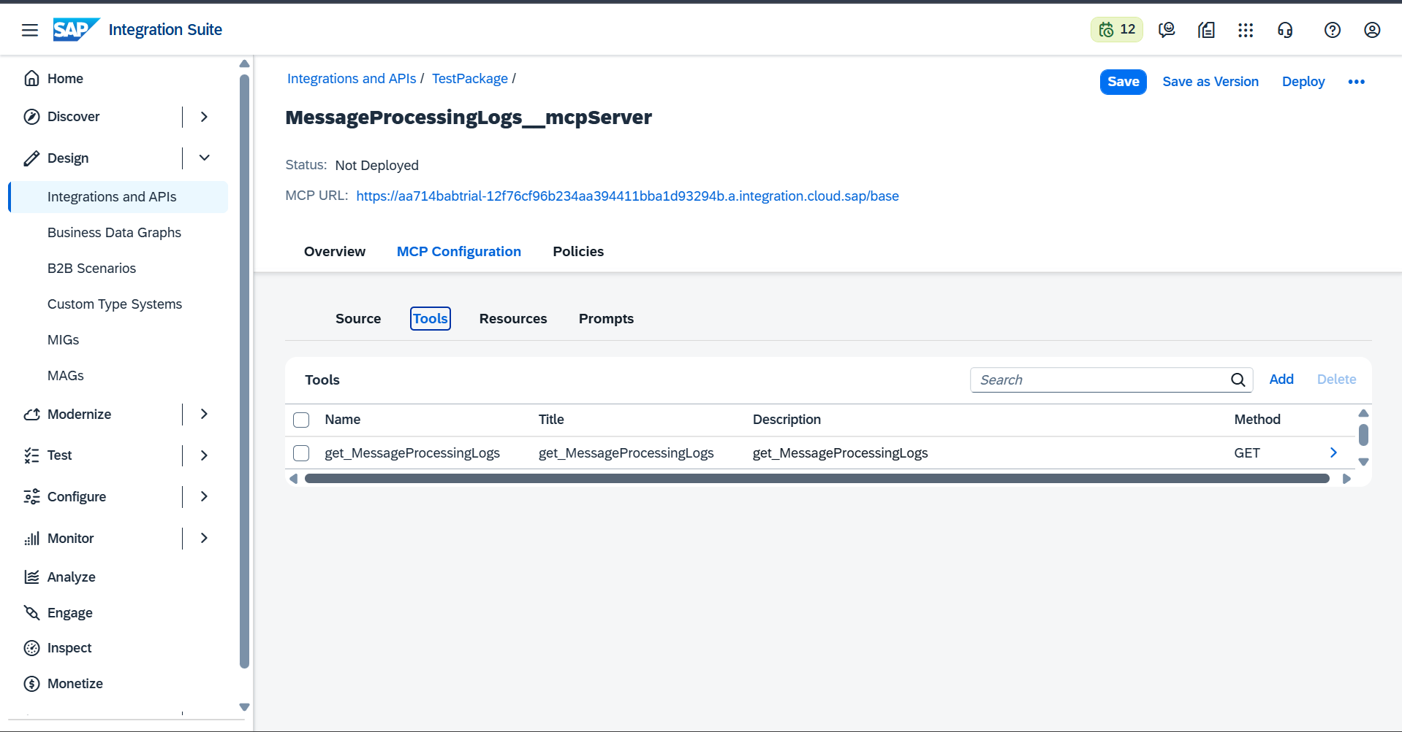
Im using vs code cline as mcp agent u canuse chat gpt or gemini here im using cline
Go to marketplace search cline and install

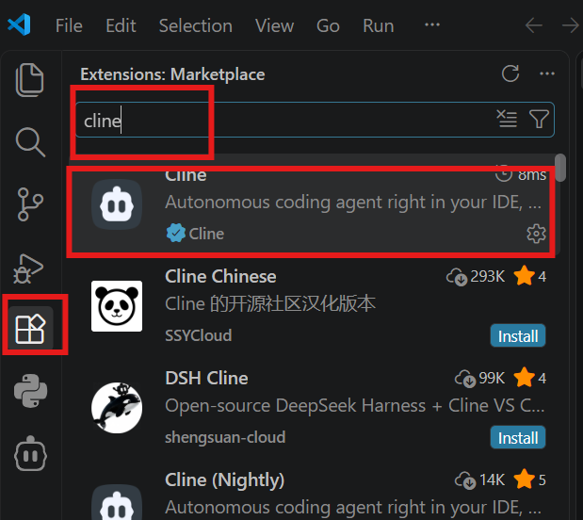

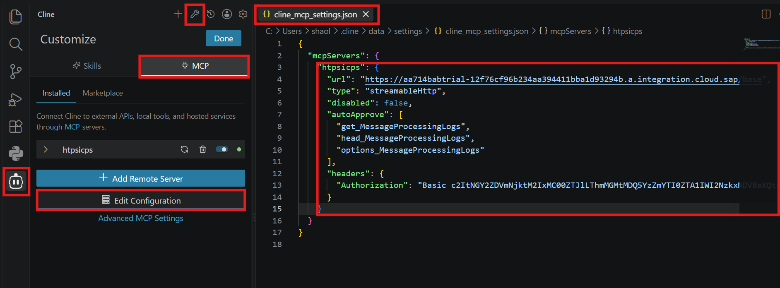

Here is our mcp server configuration once write you details url and base 64 encoded authorization save it and it will create mcp server see left sift httpsicps is green colour
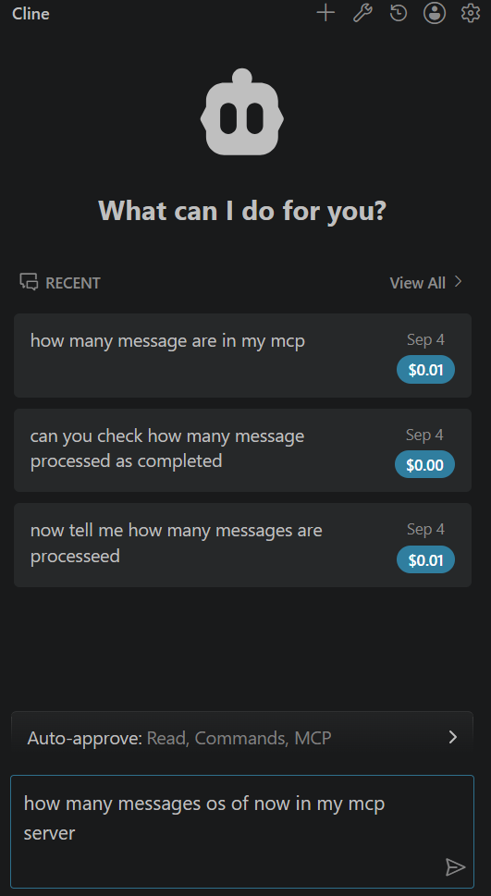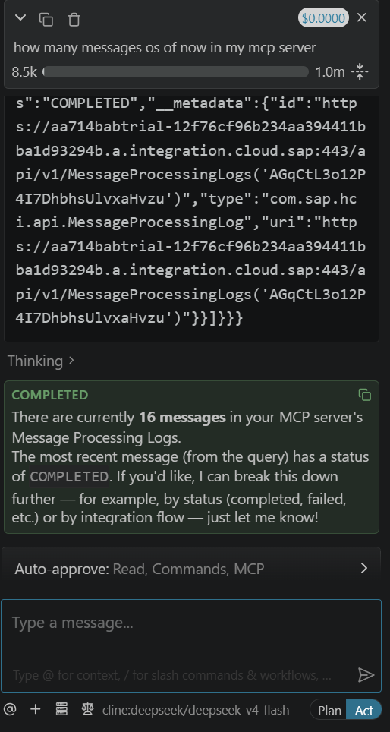

Working as expected
Now we are going to see 2 mcp type
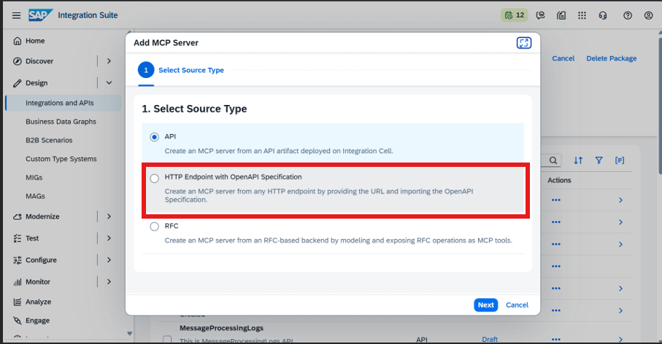
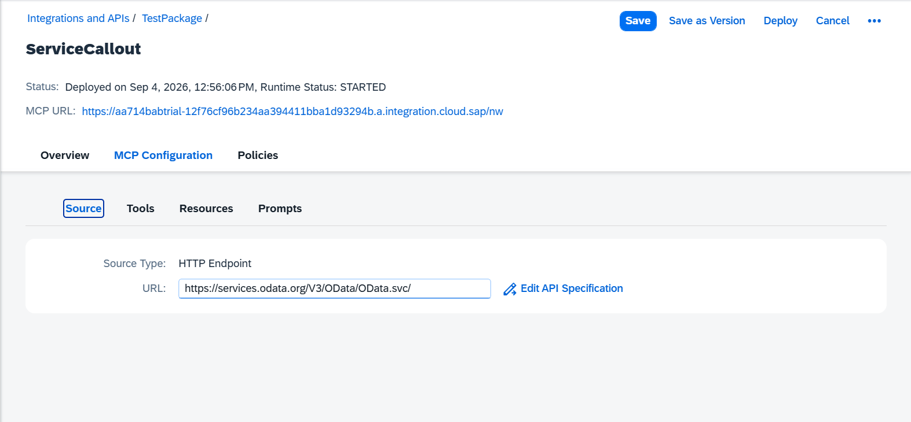
Here im using northwind’s odata but we have to provide open specification in that case what I going to do is like down load metadata while accessing the url apped /$metadata is likehttps://services.odata.org/V3/OData/OData.svc/$metadata
Copy and save it in notepad with edmx extension.
After what I have done is like I have created another demo odata api and gone to resource tap instead of adding resources I have imported a metadata
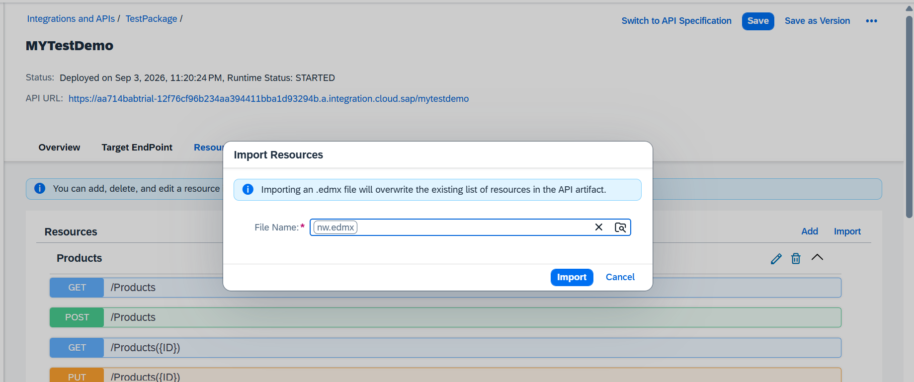
Once imported go to swith api specification which is in the top right corner
It will give openapi specification download that yaml .
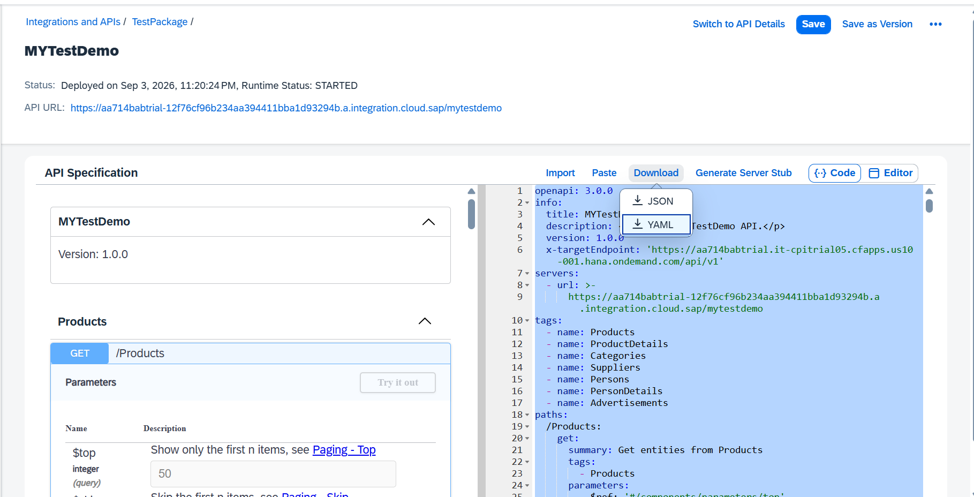

Open your mcp server Northwind Service next to url use edi specification
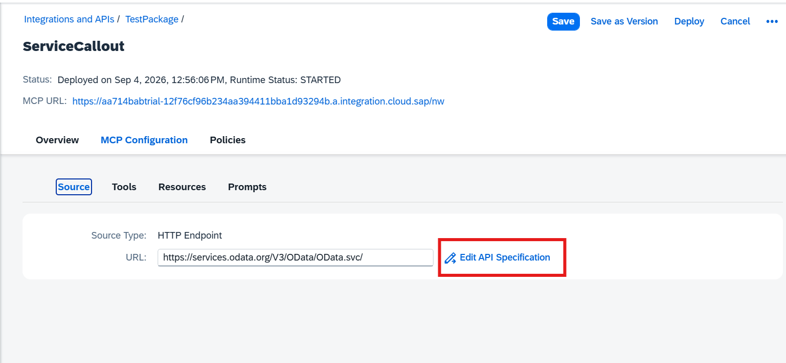
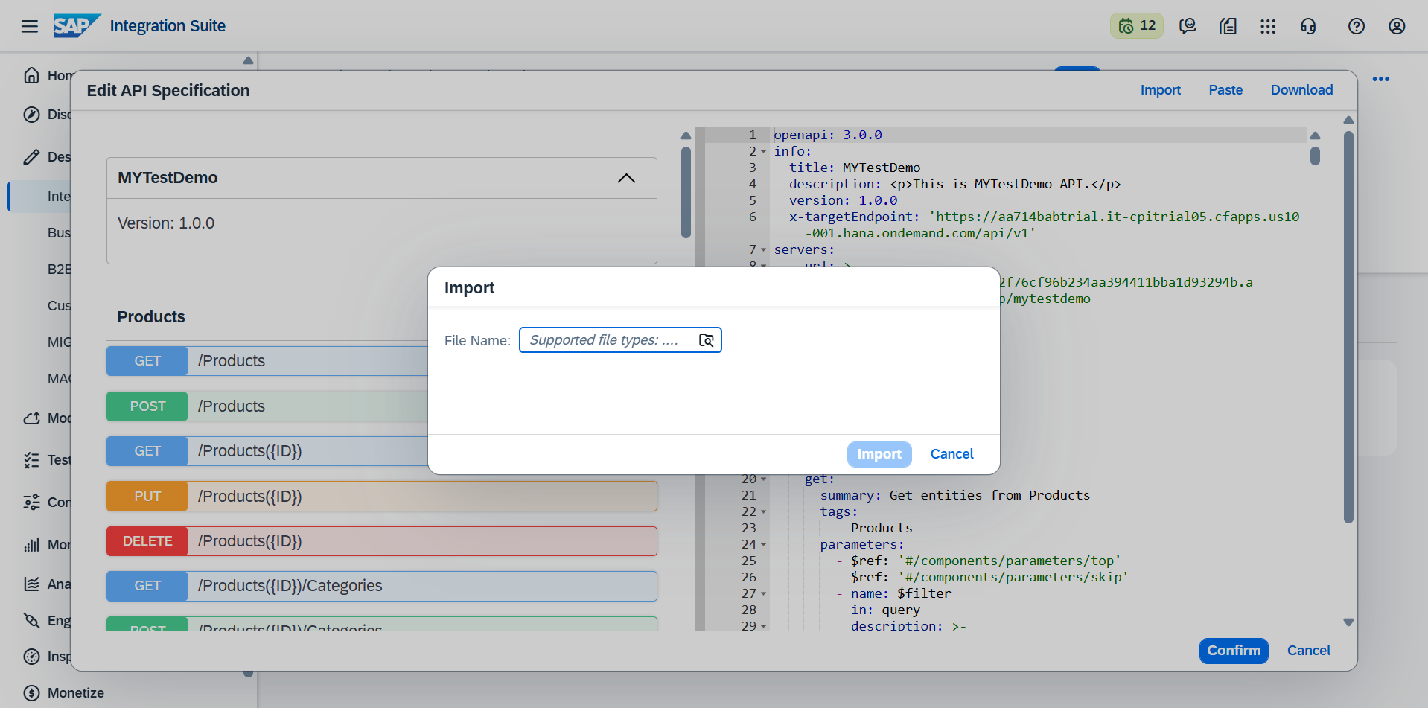
Then import the downloaded yaml all resources will be created. Save and deploy and I m going to edit configuration in vs code by adding our new northwind mcp
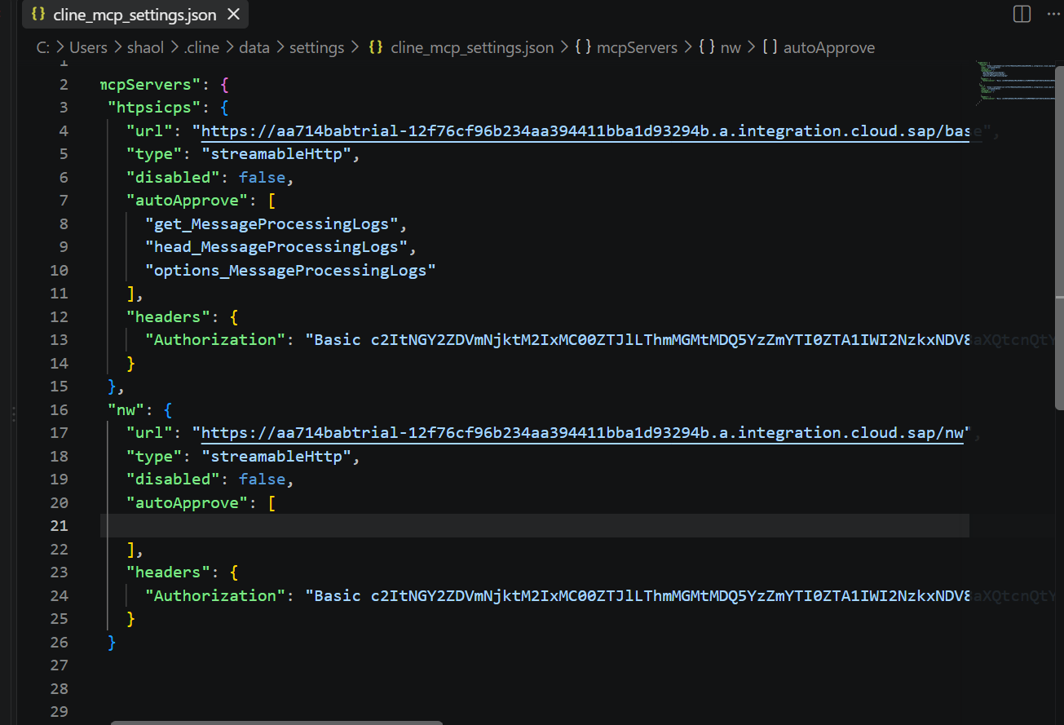
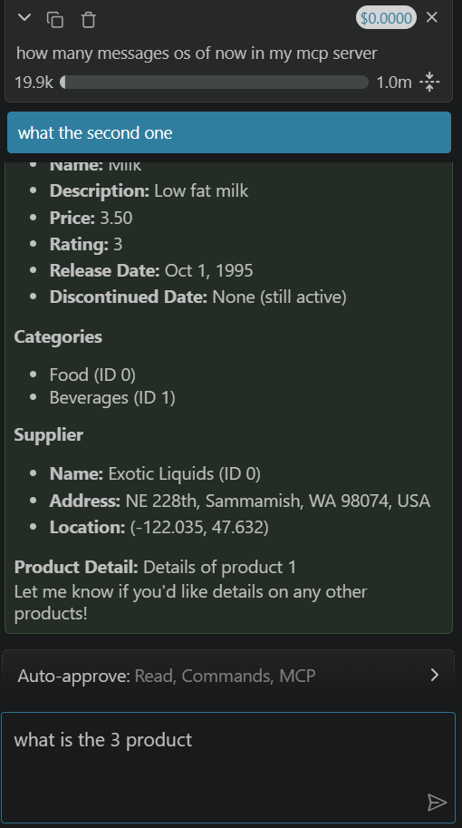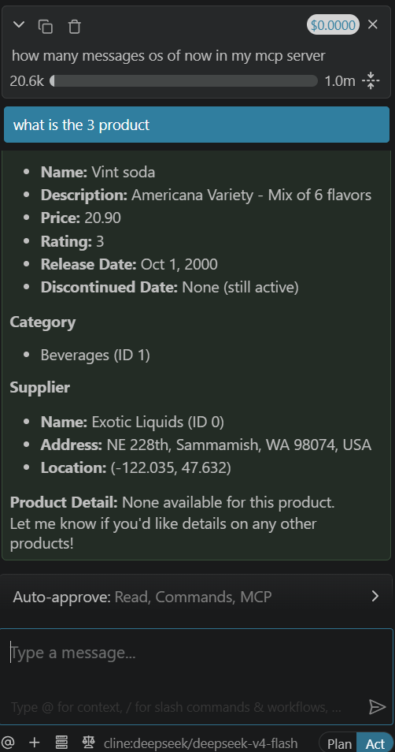
Working as expected thankyou

